Use Case for: caGrid Transfer Service
NCIA

Last Revised: | 7/08/2008
Produced By: | NCIA team

Document Approvals
The list contains the name and contact information for the core project team and any key stakeholders who have an interest in the success of the project. An “S” identifies persons responsible for approval from the stakeholder groups. Sign off of the document would be required when a decision is made not to take action for defined gaps.

S | Name | Role
S | Anand Basu | NCICB Engineering Manager
 | David Palmer | Project Manager
 | Jennifer Zeng | Technical Lead
 | Larry Holeman | Requirements Analyst
S | John Freymann | Customer Liaison
S | Anand Basu | NCICB Engineering Manager

Revision History
When you make a change to a document, you must add an entry to this Revision History table and you must manually type the Last Revised Date on the front cover.

Date | Version | Description | Revised by
04/01/2008 | 1 | caGrid Transfer Service that allows data to be retrieved from a grid service without using a gridFTP service | Larry Holeman
07/08/2008 | 2 | Added the security validation use case | Larry Holeman
Copyrights and Trademarks
© Copyright 2008 by NCICB, caBIGTM. All rights reserved.

Table of Contents
1. Use Case: caGrid Transfer Service 1
1.1 Use Case Diagram 1
1.2 Brief Description 1
1.2.1 References 1
1.4 Preconditions 2
1. External System/user has established connection to the caGrid and is communicating with NCIA 2
1.5 Basic Flow of Events 2
1.6 Post Conditions 2
2 Use Case: NCIA_Data_Services 3
2.1 Brief Description 3
2.2 Preconditions 3
2.3 Basic Flow of Events 3
2.4 Alternative Flows 4
2.4.1 Alternative Flow 1: Query for Metadata 4
2.4.2 Alternative Flow 2: Query for AIM data 5
2.5 Exceptions 5
2.6 Post Conditions 5
2.7 Special Requirements 5
2.8 Data 5
3 Use Case: NCIA Credential Validation Service 6
3.4 Brief Description 6
3.5 Preconditions 6
3.6 Basic Flow of Events 7
3.7 Alternative Flows 7
3.8 Exceptions 7
3.9 Post Conditions 8
3.10 Special Requirements 8
3.11 Data 8

Use Case: caGrid Transfer Service

Use Case Diagram
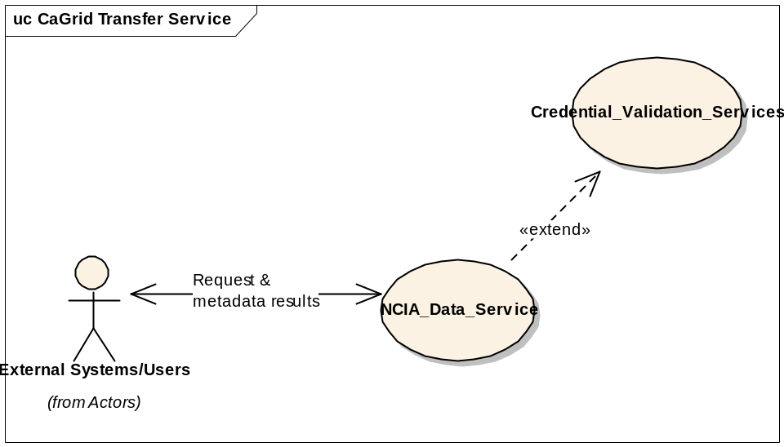

Brief Description
This Use Case describes the capability to provide the ability for users and systems to query via the NCIA data service API and access one or more images and other data objects across the grid. An external user at remote sites uses their external systems such as I-Response, VirtualPacs, and XIP Host to access NCIA Image repository through the NCIA caGrid. The systems that have a diverse configurations and software will convert their request to the NCIA query standard (CQL) for transmission.
Comment: The first phase of implementation will allow access to public data only by filtering out any private collections.

References
- Future request Tracker (https://gforge.nci.nih.gov/tracker/?func=detail&group_id=312&aid=6867&atid=1285)
- 7189 Grid Security https://gforge.nci.nih.gov/tracker/?group_id=312&atid=1285&func=detail&aid=7189
- (http://www.cagrid.org/nwiki/index.php?title=CaGridtransfer)
- NCIA Data Security for caGrid Transfer Working Paper L:\NCICB\NCIA\Tracker Supporting Material\7189-Grid Security

  - Primary Actors
External user/System that utilizes a backend conversion process to convert their query request into the NCIA standard query request (CQL).

Preconditions

External System/user has established connection to the caGrid and is communicating with NCIA
- External System/user has logged on to the workstation with their grid credentials
- All access to NCIA over the caGrid is from a provisioned Grid user
- Grid User accounts and NCIA User account IDs have been synchronized

Basic Flow of Events

NCIA shall provide an NCIA_Data_Service that accepts requests from external users/sources and return data based on the request. UC: NCIA_Data_Service

NCIA shall provide a NCIA_CREDENTIAL_Validation_Service that validate and certify that the external user has authority to access NCIA data prior to image retrieval and transmission. UC:NCIA_Credential_Validation _Service

Post Conditions

  - Requirements

    - Requirements for (6867): NCIA system shall provide the ability to down load a group of images over the caGrid Infrastructure.

- (6867.1) NCIA shall provide the capability to accept selection criteria in a request for data from external users/sources and return domain Metadata based on the request.
- (6867.2) NCIA shall provide capability to accept selection criteria in a request for images from external users/sources and return images based on that request.
- (6867.3) NCIA shall provide the capability to accept selection criteria in a request for AIM data from external users/sources and return AIM data based on that request.
- (6867.4) NCIA shall provide the capability to validate a user access to data prior to data retrieval.
- (7189.1) The NCIA system shall filter unauthorized requests for private data from a query based on the user’s authorization profile.
- (7189.2) The NCIA system shall notify caGrid users (the requester) of unauthorized requests for data.
- (7189.3) The NCIA system shall evaluate each query for proper access to data.

Use Case: NCIA_Data_Services

Brief Description
The purpose of this Use Case is to facilitate the acceptance and transfer of metadata to an external system/user. NCIA will provide NCIA services that accept requests from external users/sources and return metadata based on the request. The external user may drill down to images of interest by resubmitting request using information/data from previous requests.

Preconditions
1. External System/user has established connection to the caGrid and is communicating with NCIA
2. External System/user has logged on to the workstation with their grid credentials
3. A worklist grid service will provide a worklist that can identify what DICOM images and associated AIM annotations are needed.

Basic Flow of Events
1. This use case begins when an external user elect to submit a request for information/data to NCIA caGrid Transfer Service.
2. NCIA checks the user grid credential (username and Password) to determine the data authorization of the user.
3. NCIA evaluates the query based on the user’s authorization profile (valid user or guest user). See UC: NCIA_Credential_Validation_Service
4. NCIA_Data_Service accepts and evaluates the request by examining the domain target, attributes, and predicate of the request to determine the query content.
5. NCIA_Data_Service accepts CQL query and process according to the evaluation results.
- NCIA maintains the user Identification for data retrieval.
- NCIA validate the query for domain compliance.
- NCIA interpret and convert the query for data retrieval.
- NCIA_Data_Service queries the NCIA database.
- If request is for Metadata (See Alternative Flow 1)
- If request is for AIM data (See Alternative Flow 2)
7. NCIA_Data_Service processes and return query results
- NCIA returns query results as CQL query result
- NCIA shall stores data and a pointer until the client retrieves it or it is destroyed.
- NCIA shall store resource information needed to operate, so it can survive a container or system restart.
- Query Results is retrieved by external system/user
- NCIA shall provide he capability for data to be delivered over HTTP or GSI-based HTTPS
- NCIA shall permit retrieval of data when identity of retriever and identity of requester match.
- NCIA shall use the caller/requester identity to protect the data.

Use Case End

Alternative Flows

2.4.1 Alternative Flow 1: Query for Metadata
- NCIA Data Service queries the local NCIA database using an identifiable image model such as the DICOM or AIM model
- NCIA Data Service shall provide the capability to query for Meta data associated with patients (Subject) cases for a particular trial.
- NCIA Data Service shall provide the capability to query for Meta data on studies associated with a specified patient
- NCIA Data Service shall provide the capability to query for Meta data on series associated with a specified study
- NCIA Data Service shall provide the capability to query for Meta data on images associated with a specified series
- NCIA Data Service shall provide the capability to query data for patients based on modality(ies), anatomical site, and collections
- NCIA Data Service shall provide the capability to create a list from metadata result
- NCIA Data Service shall provide the capability to open a database connection and query the database to get DIACOM/AIM file path
- NCIA Data Service provide the capability to retrieve one or more of the series based on the CQL query
- NCIA Data Service provide the capability to convert selected items into a zipped transfer package
- NCIA Data Service shall provide the capability to return Query results as CQLQuery Results

Alternative Flow 2: Query for AIM data
- External System/user call NCIA Data Service to retrieve associated AIM based on the selected DICOM Id using the AIM’s model.
- NCIA Data Service retrieves AIM Data from database and send back AIM data in XML format

Exceptions
1. Exception 1: No Data Available for Requested Query
Returns a message stating that “There no data available for available Request”
End exception 1
2. Exception 2: Request unrecognizable
Returns a message stating that “Request cannot be evaluated, modify request and resubmit”
End exception 2
3. Exception 3: Access Denied
Returns a message stating that “You do not have permissions to access requested data”
End exception 3

Post Conditions
1. Post Condition 1:
The requested images are ready to be sent.

Special Requirements
None

Data
1. Data Request Sample
The request will be converted regardless of source to a CQL Query Format.
Example: Find Patient with Patient Name = “John Doe” AND Patient ID = “12345”
<Target name=”gov.nih.nci.ncia.domain.Patient”>
<Group logicRelation=”AND”>
<Attribute name=”patientName” predicate=”EQUAL_TO” value=”John Doe”/>
<Attribute name=”patientid” predicate=”EQUAL_TO” value=”12345”/>
</Group>
</Target>

2. Domain Data Objects
a. ClinicalTrialSponsor
b. ClinicalTrailProtocol
c. ClinicalTrailSubject
d. ClinicalTrailSite
e. TrailDataProvenance
f. Patient
g. CurationData
h. Study
i. Annotation
k. Equipment
l. Series
m. Image

Use Case: NCIA Credential Validation Service

Brief Description
This use case identifies the scenarios for users to access NCIA public and private data through the caGrid Data Transfer (GDT) services. The query is from an outside user who:
  - Is provisioned (has an account) on the grid but is not provisioned (does not have an account) on NCI NCIA
  - Is provisioned (has an account) on NCI NCIA for public data only and is provisioned (has an account) on the grid
  - Is provisioned (has an account) on NCI NCIA for public and private data and is provisioned (has an account) on the grid
  - Is not provisioned (does not have an account) on the grid or NCI NCIA (guest)

Preconditions
- All access to NCIA over the caGrid is from a provisioned Grid user
- Grid User accounts and NCIA User account IDs have been synchronized

Basic Flow of Events
  - If the user is not provisioned on the NCI instance of NCIA then:
- NCIA applies a filter to remove all private data
- The user is returned public data only
  - If the user is provisioned on the NCI instance of NCIA but has no authorization to private data then:
- If the Query contains request for both private and public data, the NCI instance of NCIA filters the private data out and returns only public data
Else
- If the Query request is for public data only, the NCI instance of NCIA returns the public data
  - If the user is provisioned on the NCI instance of NCIA and has authorization to private data then:
- If the Query contains a request for private and public data but the user has no authorization to the private, the private data is filtered and only public data is returned.
Else
- The Query contains a request for private data but the user has no authorization, Query Error A is returned,
Else
- If the Query contains a request to private and the user has authorization to the private data, the data requested is returned including any private data requested.
  - If the user is not provisioned on the grid or NCI NCIA then:
    - The user enters the system (caGrid and NCI NCIA) as a guest.
    - NCIA applies a filter to remove all private data.
    - The user is returned public data only.

Alternative Flows
none

Exceptions
Error Id | Condition | Message | Action
A | Not authorize to access data | There is not data available that matches your request.  Please contact NCI Help Desk at “URL Here” | Query is cancelled
B | No data/image matches query | Please revise your query | Query is cancelled
C | Database is not available |  | Query is cancelled
D | File System is not available |  | Query is cancelled

Post Conditions

Special Requirements

Data

